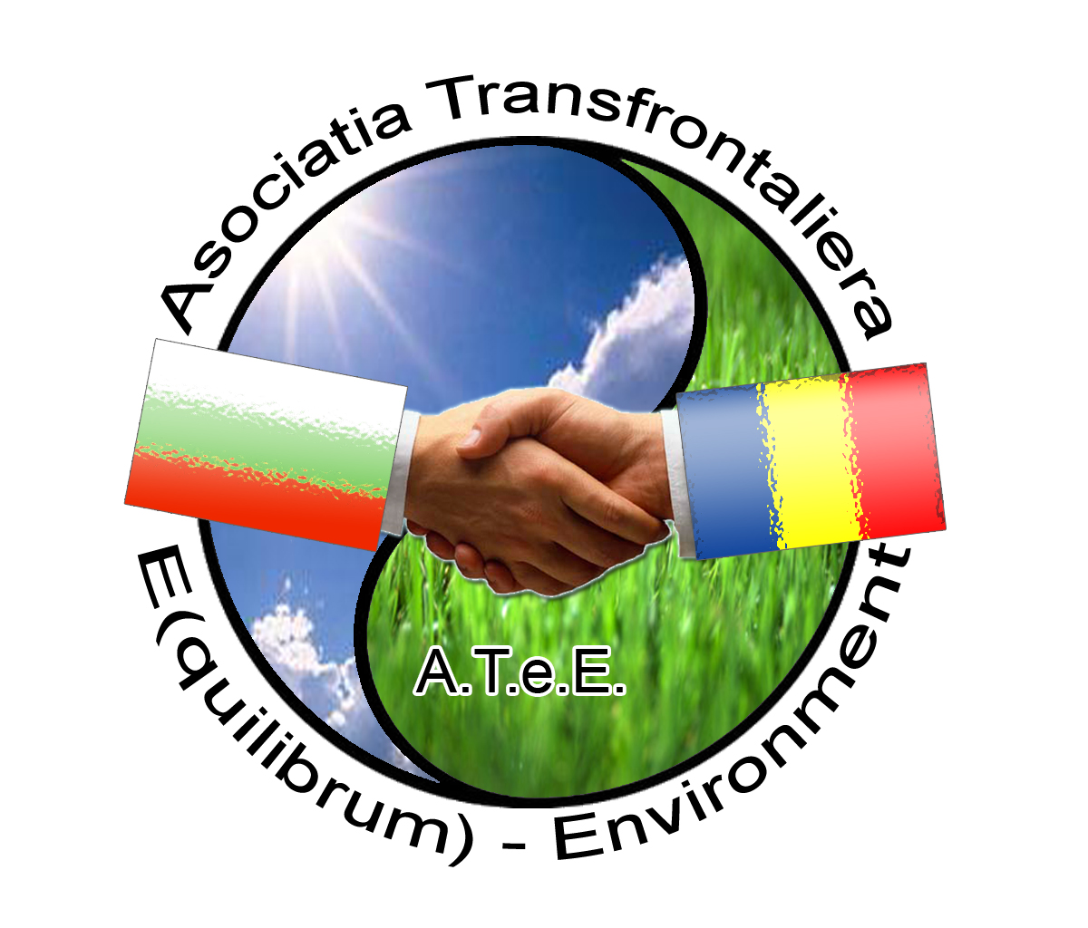 | Cross-Border Association E (quilibrum) ATeE  Cluster Electrotechnics & Environment  Stefan cel Mare street, no 12, Craiova, Dolj county, Romania  tel: +40-251-412775; Fax: +40-251-418882;  e-mail: office@ipacv.ro; web site: www.atee.ro  for regional development trough innovation, partnership, technology transfer

The Electrotechnics & Environment Cluster is the association of electronics and environment monitoring companies of Romania, situated in S-W of Romania and aims at promoting and protecting the Romanian electronics, automation, electrotechnics, environment protection business environment, as well as the professional and commercial interests of its members.
The Electrotechnics & Environment Cluster include 24 companies, the University, Local Administration, 2 Research Centres and is a support pillar of regional development through innovation and technology transfer. It was developed by ARIES Oltenia as proffessional association and IPA CIFATT Craiova as business and technology incubator and Ro4Europe, partner Enterprise Europe Network.
Oltenia Region, S-W of Romania, the territory between the Danube, the Olt river and the Southern Carpathians is historical province. Oltenia region have 5 counties: Dolj (important town: Craiova), Valcea (Ramnicu Valcea), Olt (Slatina), Gorj (Targu Jiu), Mehedinti (Drobeta Turnu Severin). The climate is temperate continental. The subcarpathian zone of Oltenia has many important touristic objectives such as: health resorts, monasteries, caves, the well-known artworks of the great romanian sculptor Constantin Brancusi: The Table of Silance, The Gate of Kiss and the Endless Column.
The mission:
- the growth of the capacity to promote the innovation, competitiveness, research, technology transfer as a regional development policy sustainable by the inter-connection of the knowledge, technologies and people.
- it is integral part of the regional politics of Oltenia through which one supports the research-development, the innovation, the technology transfer the founding and the development of the enterprises and specially the SMEs with activity based on a greater added value, Business Incubators, the technology transfer entities, acknowledging them the status of “spinal column” of the regional economy;
- offers information, specialized consultancy, starts events, meetings and professional contacts;
- proposes the collaboration among those who intermediate business relations and the politic authorities at a regional and local level, with the purpose to put into practice a strategy for the support of the business environment based on cooperation and transparency;
- promotes and participates at the implementation of the informational society and of the society of knowledge in the region of Oltenia;
- assures the promotion of the competitiveness of the industry
Electrotechnics & Environment Cluster is a flexible structure, open, based on good regional, national/international practices
- that is based on the supplying of services for the business environment and especially in the domain of innovation, technology transfer,
- that gives assistance to innovative enterprises, especially to those small and medium, as well as with potential enterprisers, in their efforts to be innovative, competitive and to face successfully the competition.
Electrotechnics & Environment Cluster is the trade/professional association of electronic and software companies in Oltenia region with the best relationship to the Universities, Local Administration, NGOs and to other business associations.
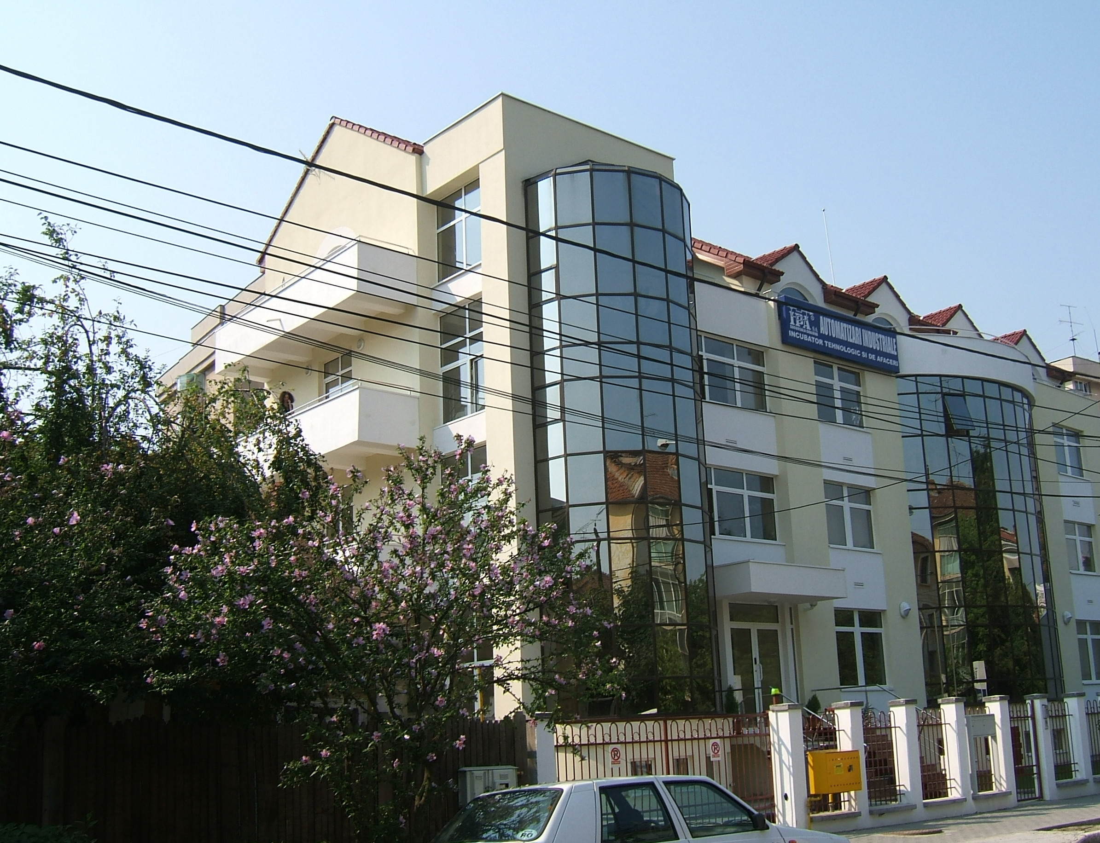
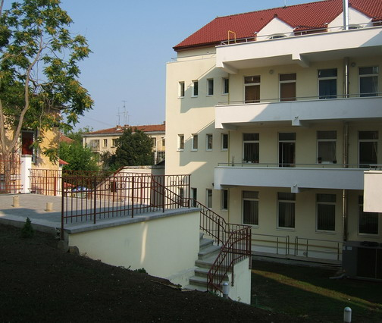

Electrotechnics & Environment Cluster is the most influential factor of the electronics and software industry in Oltenia Region. It has developed a regional strategy to increase the region hi-tech potential and turning Oltenia region into an important software producer and exporter globally and research funds redirectioning towards the SMEs.
Electrotechnics & Environment Cluster has developed activities for the promotion of its members' products and business relationships. One of the most important and strategic objectives of our association is to develop cooperation relations between Romanian and other countries companies.
Main activity domain:
- Engineering, software research and development for automation and IT systems, e-content
- "turn key" solutions for the developed systems
- Consultancy and software distribution; cooperative work solutions (for projects, etc.),
- Internet marketing and promotion, business consulting, multimedia, translation,
- Web Business Solutions - Ad Management, Affiliate Programs, Online Auctions, Blog, Bookmark Management, Calculators, Calendars, Chat, Classified Ads (General Classifieds, Autos Classified, Business Listings, Employment, Personal Classifieds, Real Estate Classifieds), Click Tracking, Content Management, Contests & Sweepstakes, Countdowns, Counters, Customer Support (Live Support), Date & Time, Discussion Boards, Documents,
- e-Commerce, Education, Email Systems (Web-based Email, Email Utilities), Exchanges (Banner Exchange, Link Exchange, Traffic Exchange),
- Networking,
- Desktop Publishing - We guarantee useful content and a professional look for all your business documents. Our network of suppliers and printers allows us to provide cost-effective services.
Consulting - We provide complete assistance for foreign businessmen, help to find money for your projects and to write and prepare your next proposal, and research on a specific topic.

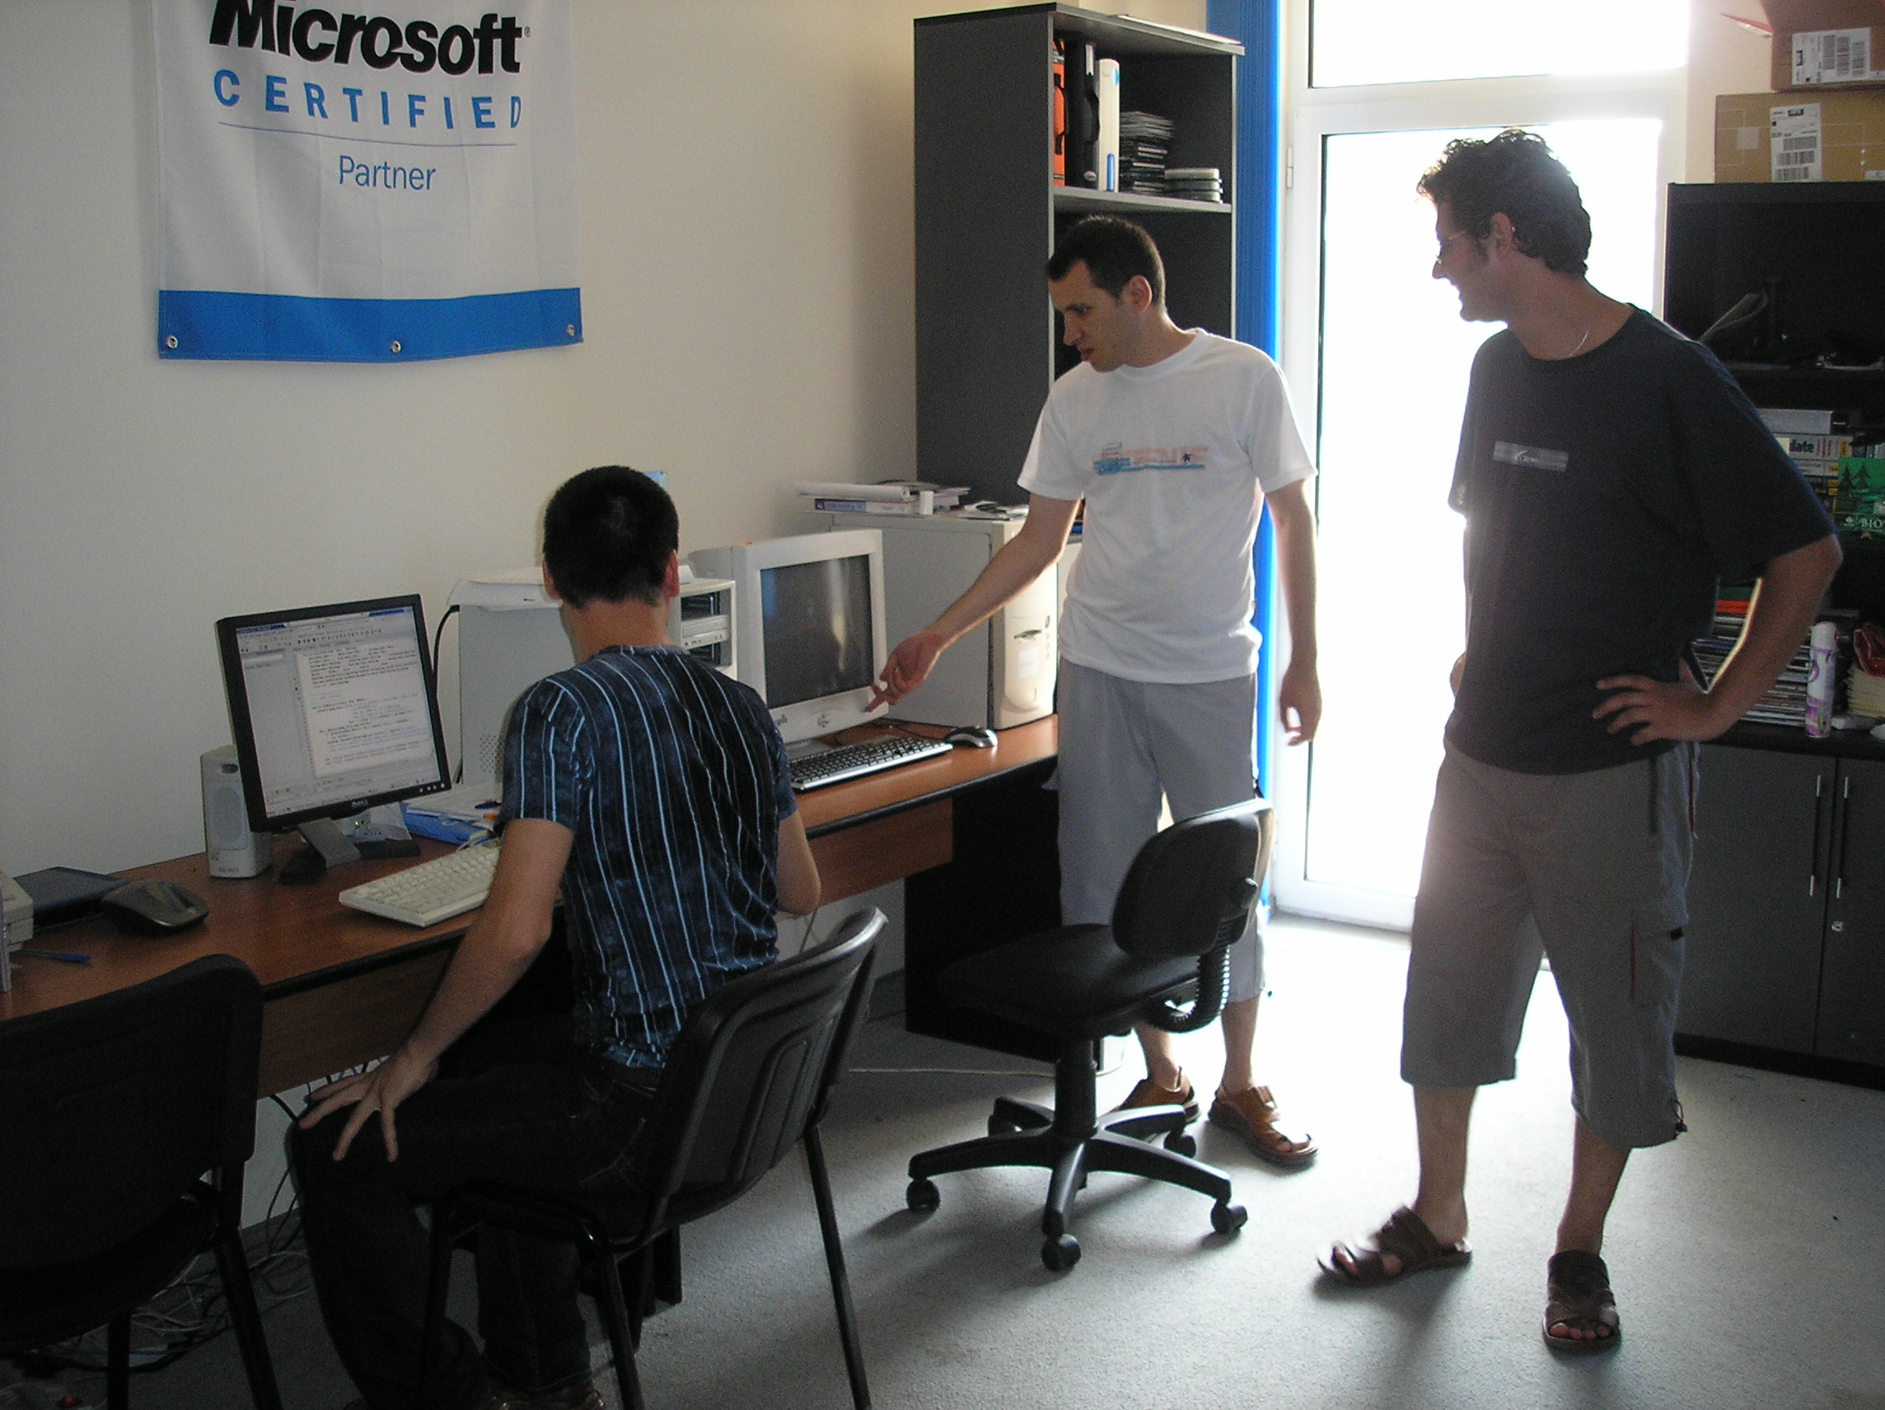 | 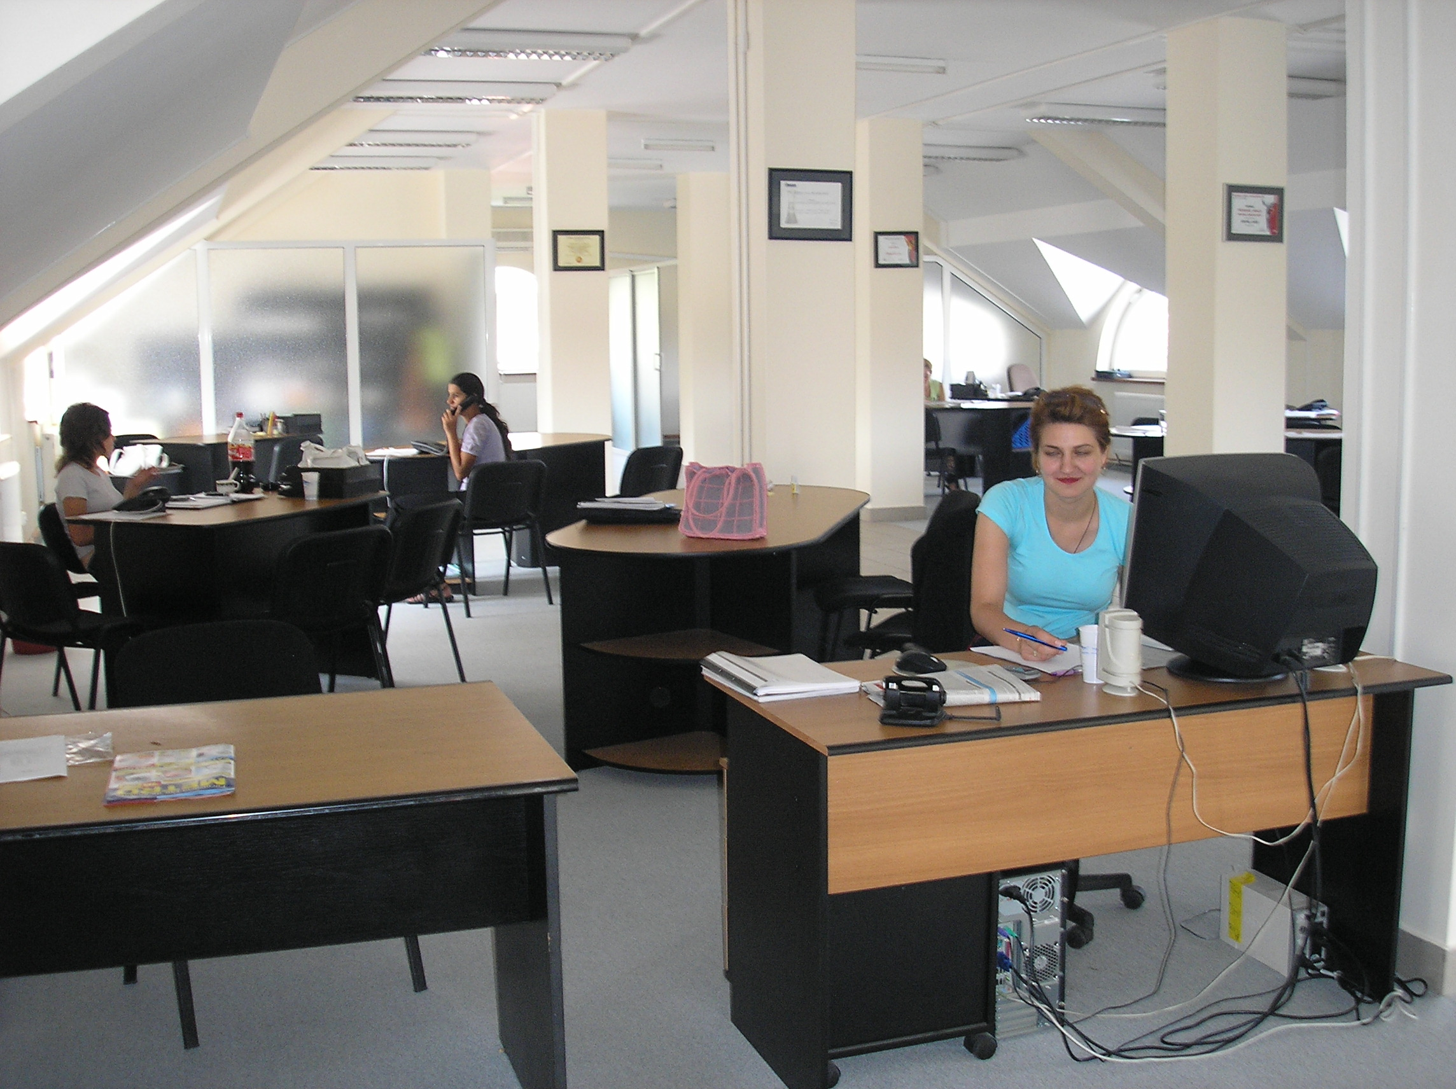 | 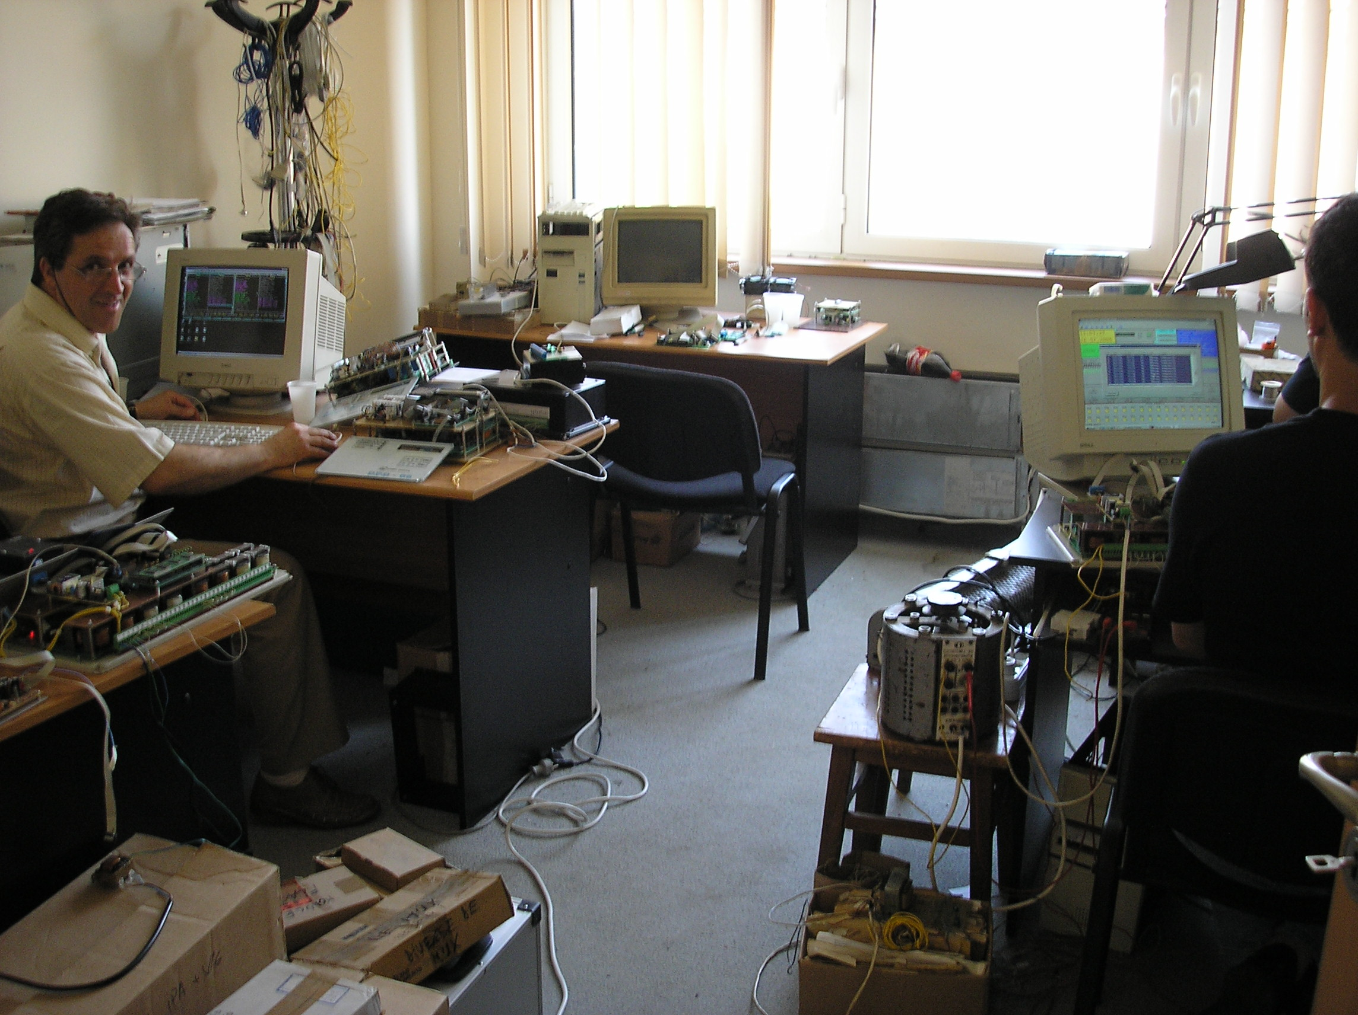 | 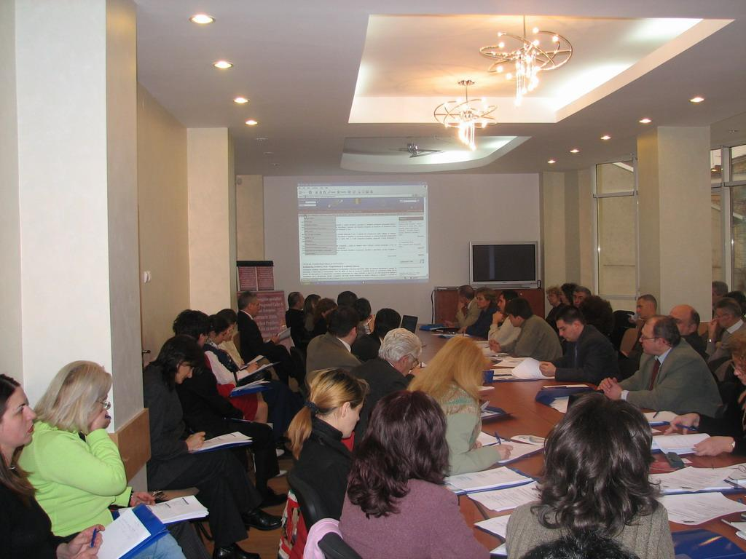

The companies involved in Electrotechnics & Environment Cluster cover a large number of activities, domains and expertise. The members have an old origin in the aviation, automation engineering, or electronic industry.
Electrotechnics & Environment Cluster has become established as consulting center in the field of :
- CAD / CAM / CAE providing quality design and engineering services for a wide spectrum of industrial applications from automotive and heavy equipment to nuclear and defense,
- automation and electrotechnics (including robotics, mechatronics) engineering
- representant for SIEMENS, Schneider, ABB and anothers greatest internationals companies
- ECAE providing electrical engineering design, analysis, prototyping and testing.
- Center of high technology transfer, providing our customers with an integrated information system for production management and control, design, stress analysis and design optimization, engineering simulations; training and technical support for the implementation of the integrated information system.
Functions "turn-key solutions" covered:
- Engineering,  - Research and Development  - Innovation, technology incubation  - Services in benefit of SMEs  - Project Management,  - Software Architect  - Programmer; Database Developer | - Monitoring & Control Systems  - IT Support Specialist and Consultant  - Technical Support  - System Integrator  - Technological Transfer  - Personal Formation  - Services

Cross-Border Association E (quilibrum) ATeE
Str. Stefan cel Mare no 12, Craiova, Dolj county, Romania; tel: +40-251-412290; +40-251-412775; Fax: +40-251-418882;
e-mail: office@ipacv.ro; web site: www.atee.ro

